Simple React App

This app contains of 2 projects

* Feont end: wich uses React.js as frontend
* Backend: which uses Node.js as a backend server

The configurations of both projects can be found in env.js files for both projects with front-end configured to run on port 3000 while backend on port 4000.

To run the app follow these steps:

1-open both projects on different terminals.

2-run npm install on both and wait to install necessary packages.

3-run npm start on both.

You can use app in two ways:

1-Using buttons located in localhost:8000

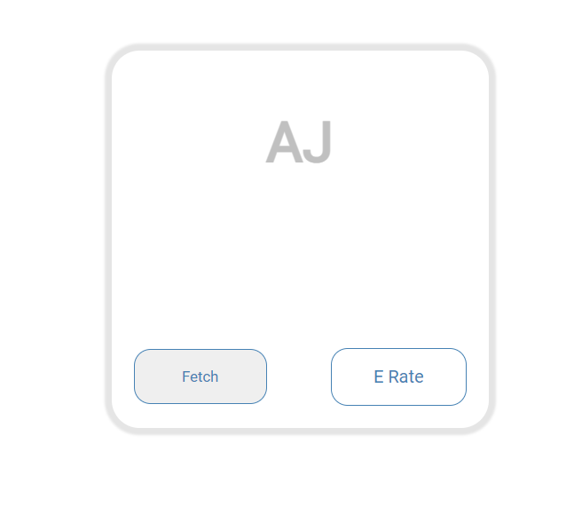

**Fetch: will fetch and store new API record in database.**

**E Rate: will get last stored exchange rate.**

2-Using Postman or any other tool to send HTTP requests

**Post method**

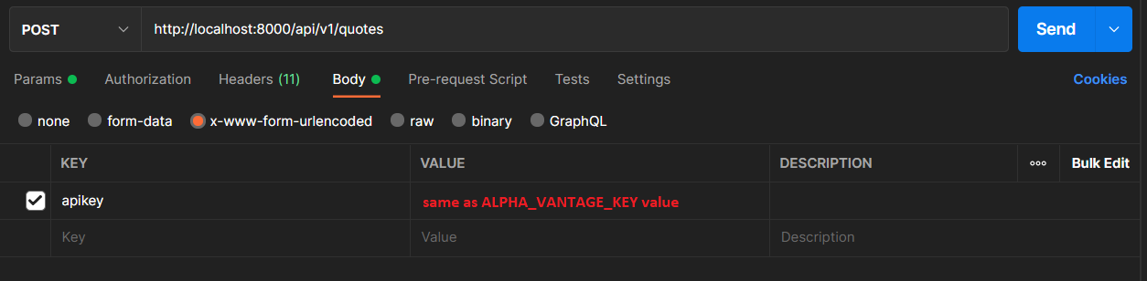

**Get method**

